# Social media And Afterlife // Synopsis

After throwing numerous ideas around and trying to recall topics which were software related I came to think of all the issues with people who died, but left their social media account ‘’alive’’.. The reason why I chose to write about this problem, which were far away from my other ideas, was because I stumbled over a couple of posts on Facebooks help page. The post answered the question what the people closest to the deceased, can do with his or hers Facebook page. This was to be found under the menu ‘’Managing a Deceased persons account’’, and then entering the post ‘’Request to Memorialize or Remove an Account’’. Facebook offers two solutions: Either you can memorialize the profile or request a removal of the account. The former has nine lines written about it, explaining why the person should chose this. The latter option, removing the profile, barely has two lines written about it. It’s easy to overlook the option because it is at the bottom of the article, and the headline’’ *How do I report a deceased person or an account on Facebook that needs to be memorialized?*’’ doesn’t refer to the direct removal of a profile but rather reporting which doesn’t seem to lead to deleting a profile. (see figure 1). This option to Memorialize makes the deceased’s profile accessible. This gives friends of the profile possibility to post on the timeline and see old pictures. Facebook gives, if applied for, a close relative the opportunity to pin a post to the timeline and accept friend requests, even though the person is diseased. If a person then want to remove the diseased Facebook, you might think you simply follow the link ‘’request the removal’’ and then send a message with the request, or maybe filling out a short formula with a check-box that ensures you’ve agreed with all sorts of terms. Well unfortunely that is not the case. Clicking the links sends you a list of requirements you have to fulfil to delete the deceased’s profile (figure 2). Once then you gathered all this, extremely personal and sensitive information, you have to submit a request. If you eventually actually succeed in removing the account, the deceased is still in the Facebook data storage. This includes messages and ‘’copies of some material’’, as Facebook puts it. This way of keeping a person alive virtually is so very strange to me, that is why I want to investigate this in my exam paper, and just the process of disappearing from Facebook or being made into a memorialize page opens up a lot of questions: How is the leftover data being stored and used? What if there are no closely related persons, does Facebook then own the virtual remainders of the diseased? Why should a person live on through a memorialize page which is able to get new friends? I plan to answer these questions, by using Facebooks help page as a reference of the difficult process.

After I began writing the first part of this synopsis, the media’s attention on Facebook has skyrocketed. It was discovered how data collected from Facebook has been used to affect the outcome of several elections. This includes the American presidency election which Donald Trump won. Trumps campaign hired Cambridge analytics to help win the election. Cambridge analytics then proceeded to steal 50 million people’s data which were acquired through Facebook. This case has led to the social media campaign #DeleteFacebook. At the same time the GDPR-Law by the European Parliament gives individuals the right to their own data. Social platforms which gather data now has to document all the data they have on you and have to document what they use it for. This resulted in people actually realising how much data is being saved. I’ve personally went on Facebook and downloaded all my data. They have a staggering 1,8 GB of data about my activities and personal information. They got all my phone contacts, they have given me subjects of interests which affects the commercials on my page. They have logged every add I’ve clicked on and on which specific time. All this I am able to see, and eventually to get deleted. But for my paper it raises another question: what if your dead? Do Facebook then own your social media remains for eternity?

Today people have given up most of their rights. In the Danish newspaper Weekendavisen the editor wrote (translated from Danish):

*‘’You wouldn’t want anybody to enter your house, snooping around looking at your personal letters and reading your diary. You wouldn’t want them to look in your family albums and seeing what medicine you have in your cupboard.’’*

This way of thinking gives a very relevant perspective. Continuing in this metaphor of thinking of your social media account as your home. When you die, your close relatives come in an clean up your place and decide what to keep, what to give to specific persons and what to throw out. On social media, Facebook will stand in front of the door asking for many different types of proof of your relations with the diseased. If you eventually get acknowledged, after some processing time, you may enter the house, but with restrictions. You can look around, but not touch or move anything because Facebook will still be the owners of all the remainders.

In the future Facebook, might look completely different. At some point Facebook might have more dead than living people, maybe #deleteFacebook have made Facebook close or maybe people will begin to adjust their life accordingly to Facebooks guidelines.

The future of social media including people naturally becoming inactive user and even memorialized profiles, gives a lot to think about. A lot of ethical questions have to be asked, while critically overlooking how Facebook deals with death and the data which is left behind. I plan to start my paper with addressing the way Facebook deals with death, and deleting an account. I would then further investigate why they want to keep inactive users by looking at the data which they collect and what it is used for, by looking at the Cambridge Analytics Case. Lastly I will discuss the future of deceased users on Facebook.

## Attachments:

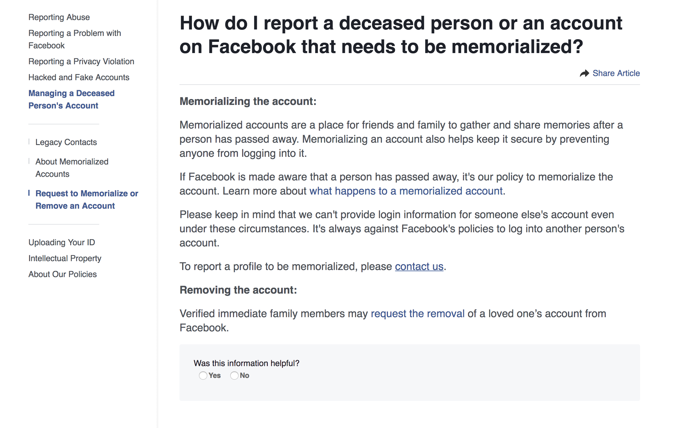

Figure Screenshot 24/3/2018 kl.12.57 <https://www.facebook.com/help/requestmemorialization>

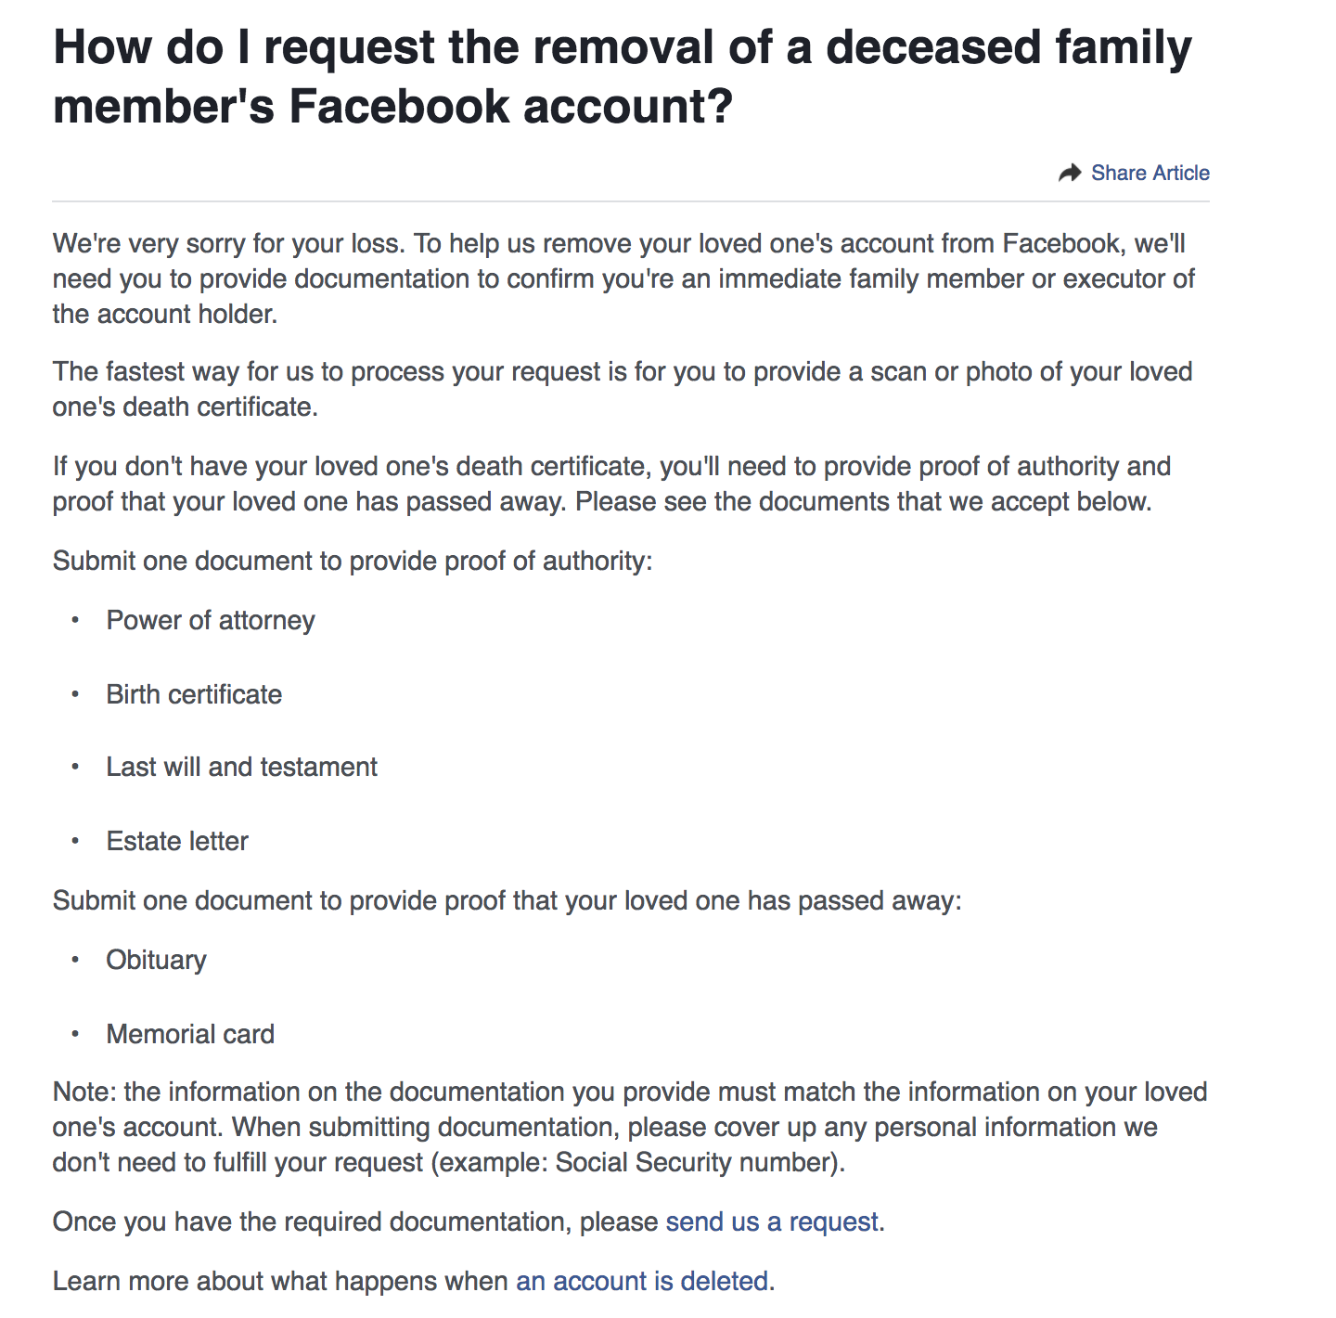

Figure Scrennshot 24/3/2018 kl.1318 <https://www.facebook.com/help/1518259735093203?helpref=faq_content>

* https://www.facebook.com/help/125338004213029?helpref=faq_content